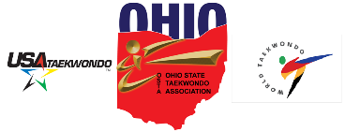 | Meeting Minutes  February 10, 2022

Call to order
A meeting of Ohio State Taekwondo Association was held via Zoom on February 10, 2022.

Attendees
Attendees included from USAT: Richard Warwick and Eric Winiger.
From OSTA: Geoff Colley, Abbie Taylor, Steve Potter, Amanda Potter, Master Larry Sanford, Master Justin Taylor, Master Jee Lee, Darin Warren, Grandmaster Robert Perry, Grandmaster Sam Naples, Masters Scott and Sarah Schwab, and Grandmaster Robert Gross

USAT
Richard Warwick started the meeting by answering questions from the OSTA. His position is that USAT and the AAU have different goals and standards. USAT is the governing body for Olympic competition. Eric Winiger indicated that the state tournament for Ohio can be held later this year. Richard Warwick said that the USAT may be willing to help with the state tournament financially. He also said that those taking tickets and similar tournament functions do not need to have a background check. Grandmaster Perry emphasized the importance of following all COVID safety protocols. USAT members left the call at 8:34 PM.

Reports
There was discussion of appointing someone to take responsibility for the association’s social media effort. Trying to find tournament sponsors was also discussed.

Unfinished business
Grandmaster Perry moved to hold the election of OSTA officers, seconded by Geoff Colley. The motion passed unanimously to have the following officers elected. They will take office on April 1st of 2022.
President: Master Justin Taylor
Vice President: Grandmaster Sam Naples
Treasurer: Geoff Colley
Secretary: Amanda Potter
Grandmaster Council: Grandmaster Schwab and Grandmaster Robert Perry
VP Central Region: Steve Potter

Adjournment:
Grandmaster Gross motioned to adjourn, seconded by Grandmaster Robert Perry. Motion passed.
The next association meeting is scheduled for March 26, 2022, via Zoom.

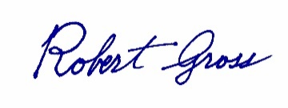 |  | February 15, 2022
Secretary |  | Date of approval

